# DAILY ASSESSMENT

|  |  |  |  |
| --- | --- | --- | --- |
| Date: | 29/06/2020 | Name: | Chesmi B R |
| Course: | **IIRS** | USN: | 4AL16EC100 |
| Topic: | **Introducing photogrammetric concepts** | Semester & Section: | 8TH SEM & A Section |
| Github Repository: | Chesmibr |  |  |

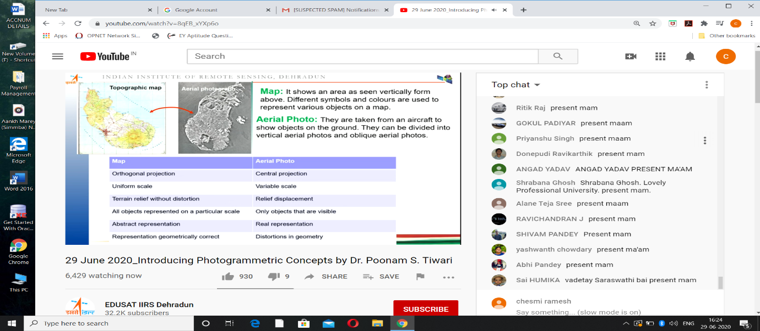

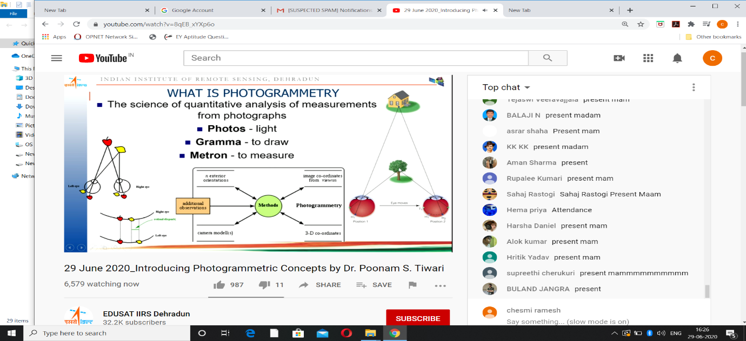

# What is Photogrammetry?

Photogrammetry is the technique that allows measurement of two points on the land or any other surface using a 2D photograph resulting in a survey map that gives a detailed idea about the spatial distribution of objects on the surface. The conversion of the mapped image can be done using the scale of the photogrammetric image. Photogrammetry also allows the mapping of motions on the surface using high-speed photography using computational models giving an increasingly accurate understanding of relative motions.

The word photogrammetry comes from the word “photo” meaning “light”, “gram” meaning “drawing” and “metry” meaning “measurement”.

Colonel Aimé Laussedat is referred to as the father of Photogrammetry who used terrestrial photographs to derive topographical maps of an area in 1849. However, the first reference of photogrammetry goes as far as 1480 when Leonardo da Vinci used the art of perspective and project geometry in many of his works. In 1865 the photogoniometer was developed by Geodesist Porro which contributed largely to the modern day photogrammetry by removing lens distortion. Meydenbauer introduced the term “photogrammetry” in the year 1893. Another landmark development was the introduction of the aerial camera, by the American Brock brothers in the year 1914, which could be mounted on a plane instead of manually holding it by the side.

**Applications of the photogrammetry**

It has been used in various fields like architecture, engineering, quality control, police investigation, manufacturing, and geology. It is used by the Archaeologists for quick plans of the large sites

Photogrammetry is also employed in engineering, especially automobiles. When accidents occur and the engineers have to determine the exact deformation in the vehicle, it’s common that the only pieces of evidence that remain left for several years are photographs from the accident scene, that were taken by police. Photogrammetry is made use of, for finding out several important things related to the accident scene like the velocity at the time of impact.

## ****How does photogrammetry work?****

Photogrammetry is based on the concept of “perspective geometry”.  It is very similar to the way that our brains convert images using the concept of intersection calculation. Photogrammetry works by using multiple images of the scene taken from different positions and angles.

Considering that the perspective center is the camera lens, whose focal length is known, and the light rays traveling through the center reflect the image of a point from the scene then the angles of the light rays from the scene can be calibrated to yield distance between the points. If at a given scene 3 points are considered whose 3D coordinates are known with reference to a coordinate system then the position of the perspective center can be determined along with the orientation of the image with reference to the coordinate system.

With the data on the position and orientation of the image that is formed the 3D vector can be determined through the perspective center in relation to each light ray. Overlapping images with known 3D vectors will help to determine the actual 3D positions of the relative points of the scene.

## ****Branches of Photogrammetry****

The most common way to classify photogrammetry is based on the position of the camera that takes the photographs to be studied. There are two basic types of photogrammetry based on the camera position. It is classified in many ways but a standard method is to split the field based on the location of the camera while taking photographs. The basis on this photogrammetry can be divided into following branches, these are –

1. Aerial Photogrammetry
2. Close range photogrammetry
3. Space photogrammetry

### ****Aerial Photogrammetry****

In this type of photogrammetry the camera is mounted on an aircraft which can take hundreds of photos of the location from various angles. For this, a precision photogrammetric camera is used to get high-quality images, which is mounted on an aircraft, UAVs or drones. Frequently satellite images are used as well. The Aerial photogrammetry mode is used for geological investigations, land and soil surveys, civil engineering for urban development, logistics, military intelligence, and others.

There are various types of photographs that can be used in Aerial Photogrammetry. They include:

* **Vertical photographs:**In Vertical photographs is where the axis of the camera is vertical to the location such that the lens axis is perpendicular to the surface of the earth. The resulting photograph is of a much smaller area but resembles the maps over flat terrains.
* **Oblique photographs:**Here, the axis of the camera is at an inclined position as compared to the vertical line. These photographs are primarily used as a supplement map. However, the area covered is relatively small and is in the shape of trapezoid. The view of the photographs is much more similar to the actual terrain unlike the vertical photographs due to the fact that axis is inclined and hence gives a fair idea of the terrain elevation.
* **Convergent photographs:** In convergent photographs, the photographs are taken with a pair of wide angled cameras with single lens or with a single twin lens wide angled camera. The camera or cameras are mounted such that the axis of the two lenses converges when tilted by a certain angle from the vertical axis much similar to the human eyes.
* **Trimetrogon photographs:**The trimetrogon photograms are an assemblage of three photographs of the location that are taken at a time consisting of one vertical and two oblique images. The direction of the vertical lens is at a right angle to the line of flight and the obliques are taken at an angle of 60 degrees from the vertical thus producing composite images from horizon to horizon.

### ****Terrestrial and Close-Range Photogrammetry****

It is also known as Terrestrial photogrammetry. In this type, the cameras are located on the grounds with the help of a tripod, are hand held, or are pole mounted. Generally, this type of photogrammetry is non-topographic, which means output is not topographic products such as terrain models or topographic maps but uses drawings instead. It even uses 3D models, measurements and points cloud. Normal everyday cameras are made use of, for measuring buildings, forensic and accidental scene, engineering structures, mines, archaeological artefacts, stock piles, and film sets. This type of photography in the computer vision community is also known as Image based modeling.

The camera is located on the ground and images taken are non-topographic in nature and is often referred to as image-based modeling. No special type of camera is required for close range photogrammetry. The usual everyday camera or phone cameras can be used to measure engineering structures, hills, rocks, stockpiles, mines, etc.

In the terrestrial and close-range photogrammetry the subject is less than a 1000ft away from the camera. There are many reasons that make CRP the preferred and often a powerful tool for geospatial professionals. The primary reason being the advent of 3D photogrammetry also called as**multi-ray photogrammetry**.

The heightened interest and use of unmanned aerial systems have furthered the use of CRP as these system rely solely on the close range photographs that are stereo-paired and then turned into 3D point clouds. Due to the fact that the terrestrial and close range photogrammetry can use the normal everyday cameras the cost involved for any study is reduced significantly.

### ****Space Photogrammetry****

It embraces all aspects of extra terrestrial photography where the camera is either fixed on earth or contained in an artificial satellite or is positioned on the moon or the planets. Photo interpretation is applied to photogrammetry in which Ariel and Terrestrial photographs are made use of for evaluating, analyzing, classifying and interpretation of images of the objects that can be seen in photographs. Therefore, Photogrammetry can be considered a combination of both measurements and interpretation.

#### ****Photogrammetry development and software****

Photogrammetry techniques have seen significant changes over the years. More changes came about with the advent of computational photogrammetry which not only automated the calculation but also increased the accuracy and rate of conversion of 2D images to 3D geometric representations of a surface.

In the initial stages, photogrammetry was more a plane table representation which then developed to the Analog form in the early and mid-1900s. With the development of computers and software, Analytical photogrammetry came into being. Now the digital form of photogrammetry is relevant and popular like the DEM or digital elevation models, digital maps and others.

Some of the current software that is being used for photogrammetry are;

* **Context Capture & Acute 3D:** This software solution allows the production of high-resolution 3D models from simple photographs often referred to as Reality Modeling.
* **Photo Modeler:** This software helps to produce 3D models and measurements from photographs by image-based modeling and close-range stereo photogrammetry.
* **Photosynth:** It analyzes digital photographs and helps to generate 3D models of photos and a point cloud of photographed object.
* **Pix4dMapper:** This software uses computer vision algorithms and photogrammetry to transform multispectral and thermal images into 3D models and maps.
* **Reality Capture:** This photogrammetric software helps to create 3D models from unordered photographs or laser scans. It is commonly used in full body scanning, gaming, surveying, creating visual effects etc.
* **Socet Set:** This software inputs stereo display photographs and automatically generates a DEM, digital feature vector data and orthorectified images.
* **Data Mapper:** DataMapper written in PHP is an Object Relational Mapper which is designed to interpret and map database tables into easy to understand objects.
* **Drone Deploy:** This is a Drone and UAV mapping platform that captures images, creates maps and 3D models.
* **DAT/EM International Summit Evolution:** This software includes CAD and GIS interfaces that provide a powerful tool for capturing and interpreting 3D information from stereo data.
* **Intergraph Z/I Imaging:** This is a traditional package used as a mapping platform that comes with a large format digital camera with increased image capture and resolution capacity.
* **KLT Associates ATLAS:** This is a 3D map data collection and editing software used for digitizing map data.
* **PCI Geomatica:** This is a remote sensing software package for processing earth observation data into 3D images.
* **GSI V-Stars:** This is a specialized photogrammetric package which is aimed to provide highly accurate measurements. It is incorporated with the camera and measurement application that takes images and interprets them with accuracy.

Due to the increasing ease and accuracy of photogrammetry, numerous applications have been evolved using this mapping technology. Photogrammetry has opened the doors to the intricate mapping required in various sciences and geological studies. This is an evolving field and will definitely see much more advancement with the integration of digital technology.

There are various software and websites that allow free access to learn and apply photogrammetry. The access to images has simplified with the use of UAV, drones, and UAS making the use of photogrammetry much simpler and accessible to most.

**Types of Photogrammetry –** These are of two types

1. Interpretative Photogrammetry
2. Metric Photogrammetry

* Plan metric
* Topographical

**Interpretative Photogrammetry** – this involves recognition and identification of objects and judging their significance through a careful and systematic analysis using photographs.

* These images created using satellite sense energy in the wavelength
* It forms a basis for remote sensing, which means an art and science of collecting information about an object without actually coming in contact with that object.
* Photo interpretation involves a study of photographic images; where as remote sensing involves photographs analysis along with data that has been collected using remote sensing instruments.

**Metric Photogrammetry –**this consists of making precise photograph measurements and other information for determining relative locations of points.

* This application consists of plain metric and topographical mapping.
* For determining distance, elevations, volume, the cross section for the compilation of topographical maps with the help of photographic measurement.
* It uses Ariel photographs, but in some cases, terrestrial photographs are used as well.

**Arial photograph classification**

Arial photographs are generally used for mapping and can further be classified into two subheadings such as the vertical and the tilted photographs.

* **Vertical Photographs** – An Arial picture taken using camera’s optical axis held in a vertical position is called a vertical Photograph.
* **Tilted photographs** – When due to certain unavoidable tilts, an axis of a camera is shifted from original vertical; the end result comes out to be a little tilted. Such a photograph is called a tilted photograph.

When the tilt of a camera’s axis is up to 3 degrees, from the plump line, the picture is called vertical whereas when the tilt is over 3degree, it is a tinted photograph.

**Advantages of the photogrammetry**

The four main advantages of the photogrammetry are as below –

* It helps in covering areas quickly
* Cost friendly, it is not expensive at all
* Easy to obtain information from air
* It even illustrates great detail

**Applications of the photogrammetry – It has various applications such as,**

* Preparation of topographical maps
* Helpful in space determination of objects on the ground.
* Acquiring military intelligence
* Applied for interpretation of geology and archaeology.
* It is of great use in the assessment of crop damage due to natural calamitous such as flood or earthquake.
* Helpful in preparation of a composite picture of a ground.
* It is even helpful in the relocation of already existing property boundaries
* Photogrammetry is even applied to the field of medicine.